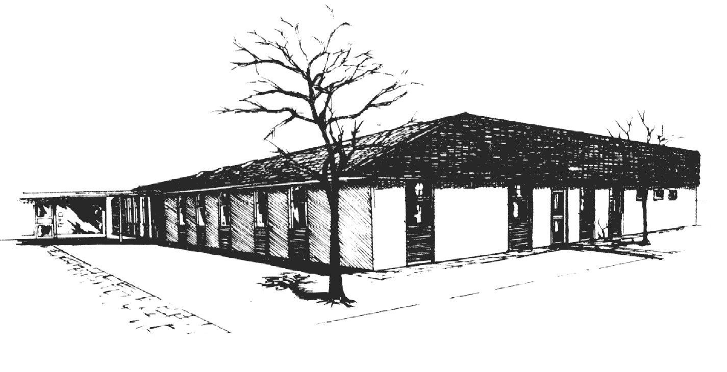

The New Hall Lane Practice

Date of Approval: 25/07/2025
Date of Review: 25/07/2026

Privacy & Fair Processing Notice

The New Hall Lane Practice

Privacy & Fair Processing Notice

Privacy & Fair Processing Notice

In compliance with the principals of the General Data Protection Regulation (GDPR), which become law of 25th May 2018, The New Hall Lane Practice makes the following declaration:

As controllers of personal patient and staff data, we pledge to be open and transparent about how data are used and that the data are handled in line with individuals’ reasonable expectations. We pledge to process the data we hold fairly, lawfully and transparently.

Disclosures required by law
In order to comply with its legal obligations, this practice may send data to NHS Digital when directed by the Secretary of State for Health under the Health and Social Care Act 2012.

This practice contributes to national clinical audits and will send the data which are required by NHS Digital when the law allows. This may include demographic data, such as date of birth, and information about your health which is recorded in coded form, for example, the clinical code for diabetes or high blood pressure.

Disclosures for medical research or health management purposes
This practice contributes to medical research and may send relevant information to medical research databases such as the Clinical Practice Research Datalink and QResearch or others – when the law allows.

Patient & Staff data processing
We will process patient data under the lawful basis under Article 6 (1)(e) and 9(2)(h) for the provision of direct patient care. Examples of where this may happen are;
- referrals to or liaison with other healthcare providers
- Contacting patients via post, telephone, mobile (including text messages regarding appointments & health information) or email

We will process staff data under the lawful basis under Article 6 (1)(b) for the performance of a contract to which the data subject is party or in order to take steps at the request of the data subject prior to entering into a contract. We may also provide staff information to occupational health providers under Article 9(2)(h) for the purposes of preventative or occupational medicine, for the assessment of the working capacity of the employee.

We may record CCTV under the lawful basis under Article 6(1)(e) for the performance of a task carried out in the public interest (e.g. prevention or detection of crime).

If you have any questions or concerns that you would like to raise with the practice, you can contact us using the following details;

Practice contact address | The New Hall Lane Practice , The Health Centre, Geoffrey Street, Preston, Lancashire. PR1 5NE
Telephone | 01772 970907
Email | lscicb-gp.pq@nhs.net
Data Protection Officer | Dr Amandeep Singh, Senior GP Partner

Where local resolution cannot be found, staff and patients have the right to lodge a complaint with the Information Commissioners Office (ICO). www.ico.org.uk

National Data Opt-out

The practice confirms to the National Data Opt-out. You have the right to object to (or opt-out of) ways in which your information is shared; both for direct medical care purposes, such as the national NHS data sharing schemes - i.e. primary uses of your information; and for purposes other than your direct medical care - so-called secondary uses. Details of these purposes and how you can opt out can be found via the website : https://www.nhs.ul/your-nhs-data-matters . You can complete a form online, by phone, or in paper.

A child is able to set their own opt-out from age 13 which aligns with the minimum age at which children can give their consent to participate in digital services as set out in data protection legislation. This is not based on any test of competence. Children under 13 and those who lack capacity are not able to set an opt-out themselves. In these cases, individuals who have a formal, legal relationship to act on behalf of them (i.e. somebody who has parental responsibility, a lasting power of attorney or court appointed deputy) are able to set an opt-out on their behalf by proxy. Special arrangements are also in place to ensure that those detained in prisons and secure settings and those where their record is marked as “sensitive” are able to set an opt-out if they wish to.

Any data sharing agreement entered into by the practice must confirm to the National Data opt-out and omit any patient who has opted-out.

Details We Collect about You

The healthcare professionals who provide you with care maintain records about your health and any treatment or care you have received previously or elsewhere; e.g. NHS Hospital Trusts, other GP Surgeries, Out of Hours GP Centres, A&E Departments and Walk-in Clinics. These records help to provide you with the best possible healthcare.
Records which we may hold about you may include the following:
- Details about you, such as your address and next of kin emergency contacts
- Your home telephone number, mobile phone number and email address
- Any contact the practice has had with you, such as appointments, clinic visits, immunisations, emergency appointments and admissions
- Notes and reports about your health, treatment and care
- Results of investigations, such as laboratory tests, x-rays, etc.
- Relevant information from other health professionals, relatives or those who care for you, or information provided to the practice by you (including that provided via our practice website).

How We Keep Your Information Confidential and Safe

Your contemporaneous GP NHS health records are kept electronically. Our GP records database is hosted by EMIS Health Ltd., which is acting as a Data Processor. All information is stored on their secure servers and protected by appropriate security, with access restricted to authorised personnel.

We also ensure Data Processors that support us are legally and contractually bound to operate, and can prove security arrangements are in place where data that could or does identify a person are processed.
We only email you or use your mobile number to text you regarding matters of medical care, such as appointment reminders and if appropriate, test results. Unless you have separately given us your explicit consent, we will not email you for non-medical matters, such as practice newsletters and other information.
We maintain our duty of confidentiality to you always. We will only ever use or pass on information about you if others involved in your care have a genuine need for it. We will not disclose your information to any third party without your permission unless there are exceptional circumstances, i.e. life or death situations, or where the law requires information to be passed on.

How We Use Information about You

Ford Medical Practice handles medical records according to the laws on data protection and confidentiality. Confidential patient data will be shared within the healthcare team at the practice, including medical, nursing and administrative staff, secretaries and receptionists. We also share medical records with other healthcare teams to whom a patient is referred; these individuals have a professional and contractual duty of confidentiality. Information is shared on a need to know basis and event by event.
Data about you is also used to:

- Manage national screening campaigns such as cervical cytology
- Manage the NHS and make payments (the data is usually de-identified)
- Check the quality of care provided by the NHS.

Referrals for Specific Healthcare Purposes:

The Practice sometimes provides your information to other organisations for them to provide you with medical services. We will always inform you of such a referral and you always have the right not to be referred in this way. These include referrals to home oxygen services, the NHS Diabetes Prevention Programme, diabetes structured education and diabetes eye screening .

Data Sharing Schemes
A number of data sharing schemes are active locally, enabling healthcare professionals outside of the surgery to view information from your GP record, with your explicit consent, should that need arise. These schemes include:

- National Summary Care Record (SCR)
- EMIS Web Local Record Sharing
- North West Ambulance Service (NWAS)
- Greater Preston Primary Care Network (PCN)
- LPRES

Data Processors:

The Practice uses Data Processors to perform certain administrative tasks for us, particularly where these involve large numbers of patients; e.g. our GP records database, which is hosted by EMIS Health Ltd; AccuRx and Iplato for sending SMS text messages; and Egton, for digitisation of paper records.

Mandatory Disclosures of Information:

We are sometimes legally obliged to disclose information about patients to relevant authorities. In these circumstances, the minimum identifiable information that is essential to serve that legal purpose will be disclosed. That organisation will also have a professional and contractual duty of confidentiality. Data will be anonymised if at all possible before disclosure if this would serve the purpose for which the data is required.
Organisations that we are sometimes obliged to release information to include:

- NHS Digital
- NHS England
- Lancashire & South Cumbria ICB
- Public Health England
- Local Authorities
- NHS Counter Fraud
- The Police Service
- The Courts
- HM Revenue & Customs
- The Driver & Vehicle Licensing Agency
- The Care Quality Commission
- The Health Service Ombudsman
- The General Medical Council.

In the event of actual or possible legal proceedings, we may need to disclose information from an individual’s GP record to a medical defence organisation.

Permissive Disclosures of Information:

Only with your explicit consent, The Practice can release information about you, from your GP record, to relevant organisations. These may include your employer, insurance companies, solicitors, Local Authorities and the Police Service.

Accessing Your Information on Other Databases:

The Practice can access certain medical information about you, when relevant or necessary, which is held on other databases (i.e. under the control of another Data Controller). These include NHS Digital’s Open Exeter database. Accessing such information would only be for your direct medical care.

Research:

The Practice sometimes undertakes accredited research projects. Where this involves accessing or disclosing identifiable patient information, we will only do so with the explicit consent of the individual and Research Ethics Committee approval.

Accessing Your Own Medical Information:

You can also sign up to have secure online access to your electronic GP record. Details of how to do this can be found on our website or by speaking to our reception staff.

